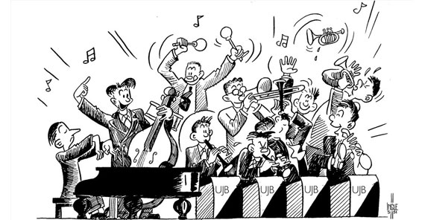

Training band Rehearsal Schedule

Tuesday night 4.15 – 5.15pm

5th Sep – no rehearsal

12th Sep – yes

19th – yes

26th – no rehearsal

3rd Oct – no rehearsal

10th – yes

17th – yes

31st Oct – yes

7th Nov – yes

14th – No

21st – yes

28th Nov – no rehearsal

5th Dec – yes

12th Dec – no rehearsal

**QMGS**

**training band**

**rehearsal schedule**

**autumn**