[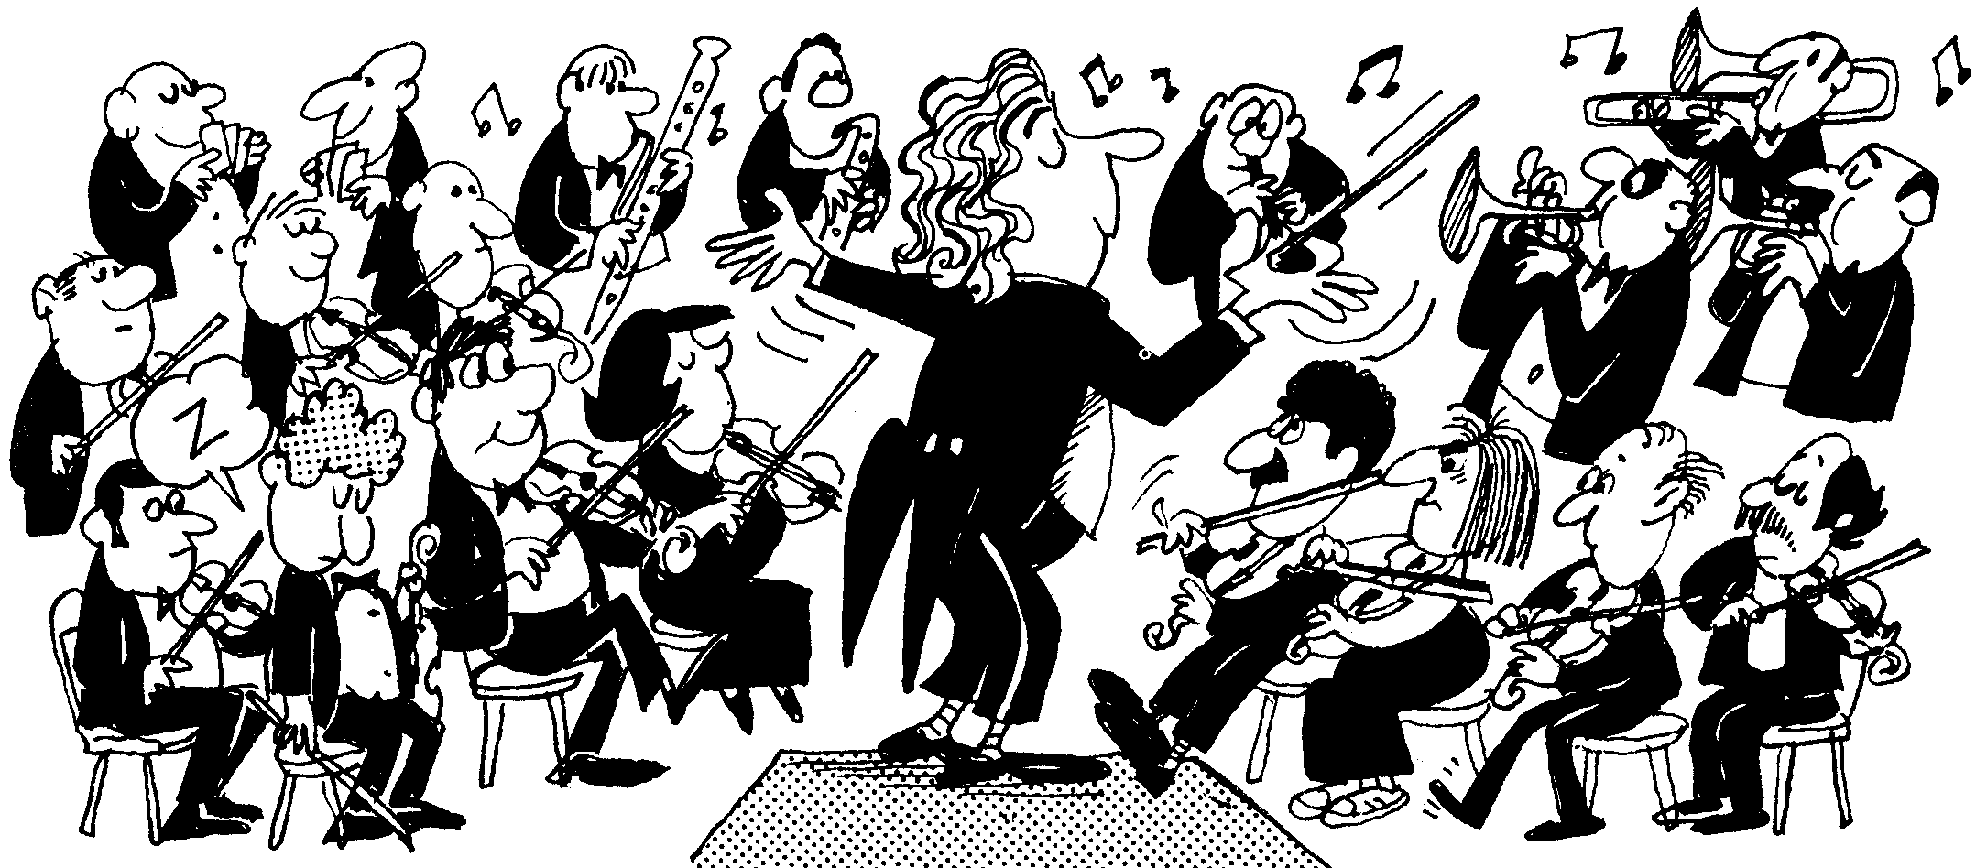](http://www.google.co.uk/url?sa=i&rct=j&q=&esrc=s&source=images&cd=&cad=rja&uact=8&ved=0ahUKEwjIkaanypPOAhVDWRoKHaMjBjYQjRwIBw&url=http://rfdo.org.uk/?page_id=200&bvm=bv.128153897,d.ZGg&psig=AFQjCNEDQ0bgRD7lirxflebW8JPLVes7tQ&ust=1469706686353353)

Orchestra Rehearsal Schedule

Monday night 4.15 – 5.15pm

Mon 8th Jan – no rehearsal

15th Jan – yes

22nd Jan – yes

29th Jan – yes

5th Feb – yes

12th Feb – yes

**19th – HALF TERM**

26th – Yes

5th March – yes

12th March – yes

19th March– yes

26th March – yes

**EASTER HOLIDAY**

16th April – No

23rd April – yes

30th April – yes

TOWN HALL CONCERT

Wednesday 2nd May 7.30pm

**QMGS orchestra**

**rehearsal schedule**

**spring**